**Garage Management system**

**College:** PPG INSTITUTE OF TECHNOLOGY

**College Code :** 7125

|  |  |
| --- | --- |
| **Team Members** | **NM ID** |
| Sridevi | ECBF3E596DA5F559B8549B13392E13BF |
| Usha | A3E49C41A1F3820AED44C56C41159E86 |
| Daveram | 292A93B46C0C451ABE048E2D8CC9A717 |
| Merwin Samson | F1E876C328DEDAFA8C3468FFF4EAD283 |

**Project Overview:**

The Garage Management System is a valuable tool for automotive repair facilities, helping them deliver top-notch service, increase operational efficiency, and build lasting customer relationships. With its user-friendly interface and powerful features, GMS empowers garages to thrive in a competitive market while ensuring a seamless and satisfying experience for both customers and staff.

**Milestone 1:**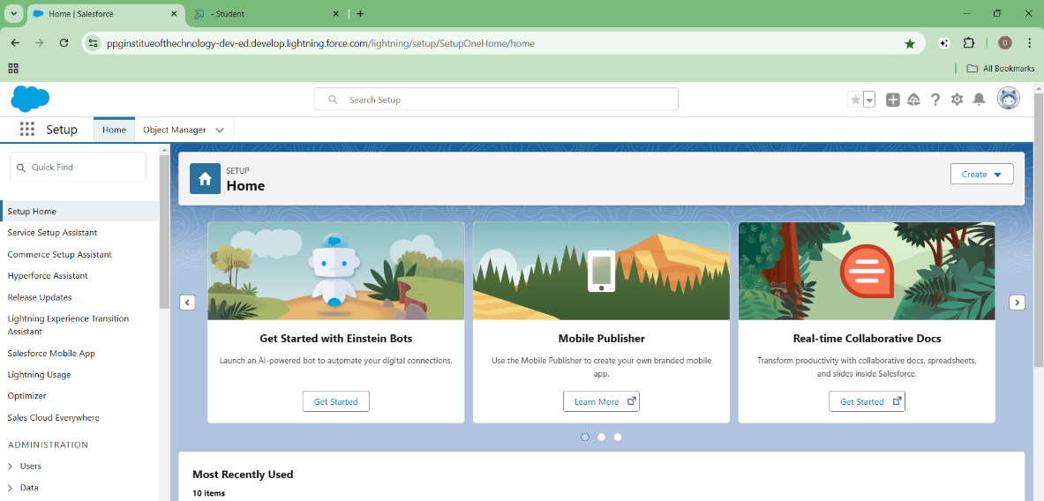

**Activity 1: Creation of Developer Account**

To start using Salesforce, I created a Developer Account by signing up on the [Salesforce Developer Signup Page](https://developer.salesforce.com/signup). The form required details like name, email, role (Developer), organization, and a unique username in the format username@organization.com. After submission, I gained access to a free environment for building and testing Salesforce applications. This step laid the foundation for exploring Salesforce features and tools.

**Activity 2: Account Activation**

After signing up, I activated my Salesforce Developer Account by verifying my email. I clicked on the "Verify Account" link, set a secure password, and answered a security question. Upon completing these steps, I was redirected to the Salesforce setup page, successfully enabling access to the platform’s features.

**Milestone 2: Object Creation**

**Activity 1: Create Customer Details Object**

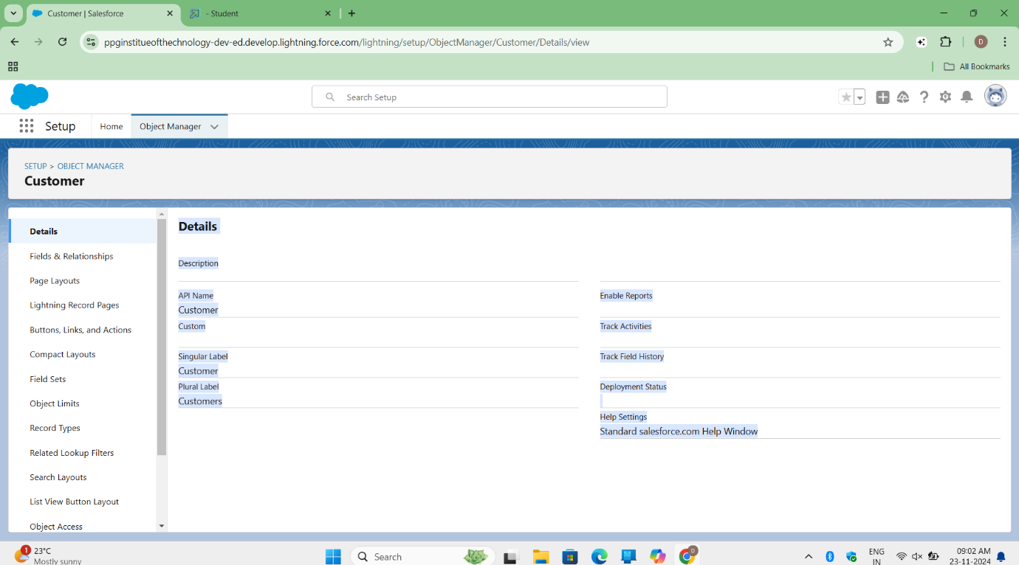

I successfully created the "Customer Details" custom object by navigating to **Setup → Object Manager → Create → Custom Object**. I configured it with the following details:

* **Label Name:** Customer Details
* **Plural Label:** Customer Details
* **Record Name:** Customer Name (Text)  
  Additionally, I enabled "Allow Reports," "Track Field History," and "Allow Search" before saving the object.

**Activity 2: Create Appointment Object**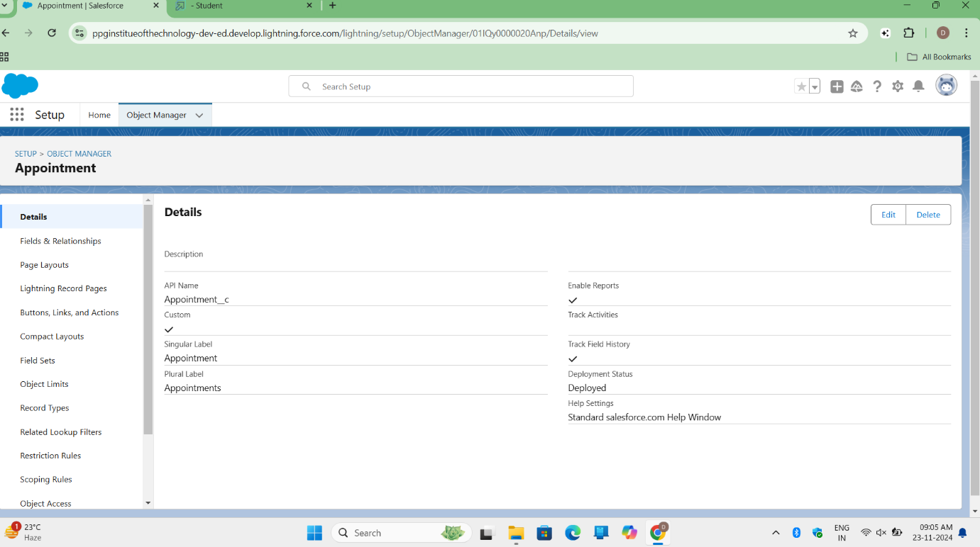

I created the "Appointment" custom object by navigating to **Setup → Object Manager → Create → Custom Object**. The configuration details included:

* **Label Name**: Appointment
* **Plural Label**: Appointments
* **Record Name**: Appointment Name
  + **Data Type**: Auto Number
  + **Display Format**: app-{000}
  + **Starting Number**: 1

I enabled "Allow Reports," "Track Field History," and "Allow Search," then saved the object successfully.

**Activity 3: Create Service Records Object**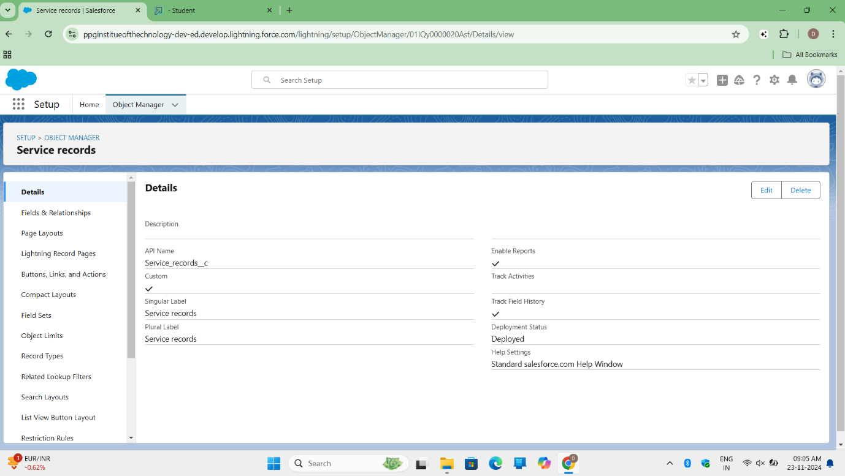

I created the "Service Records" custom object by navigating to **Setup → Object Manager → Create → Custom Object**. The details I entered were:

* **Label Name**: Service Records
* **Plural Label**: Service Records
* **Record Name**: Service Records Name
  + **Data Type**: Auto Number
  + **Display Format**: ser-{000}
  + **Starting Number**: 1

I enabled "Allow Reports," "Track Field History," and "Allow Search," and then saved the object successfully.

**Activity 4: Create Billing Details and Feedback Object**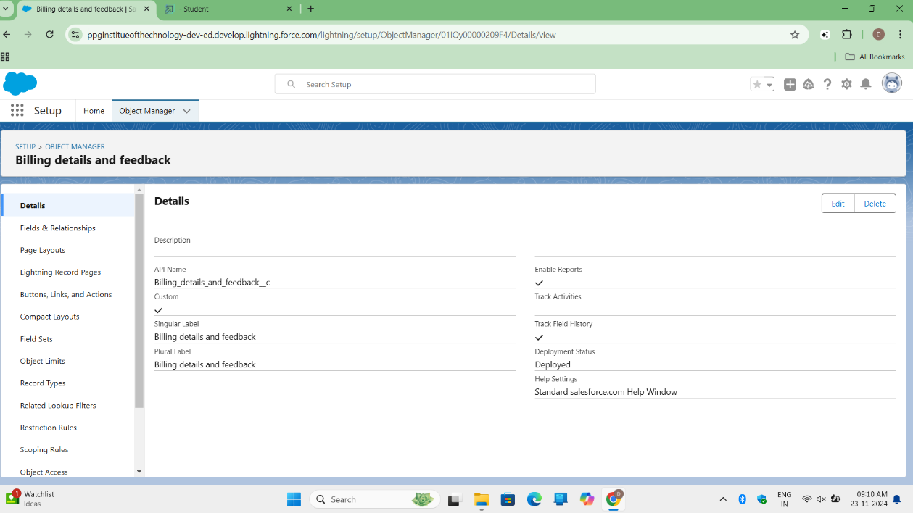

I created the "Billing Details and Feedback" custom object by navigating to **Setup → Object Manager → Create → Custom Object**. The details I entered were:

* **Label Name**: Billing Details and Feedback
* **Plural Label**: Billing Details and Feedback
* **Record Name**: Billing Details and Feedback Name
  + **Data Type**: Auto Number
  + **Display Format**: bill-{000}
  + **Starting Number**: 1

I enabled "Allow Reports," "Track Field History," and "Allow Search," then saved the object successfully.

**Milestone 3- Tabs**

**Activity 1: Creating a Custom Tab (Customer Details)**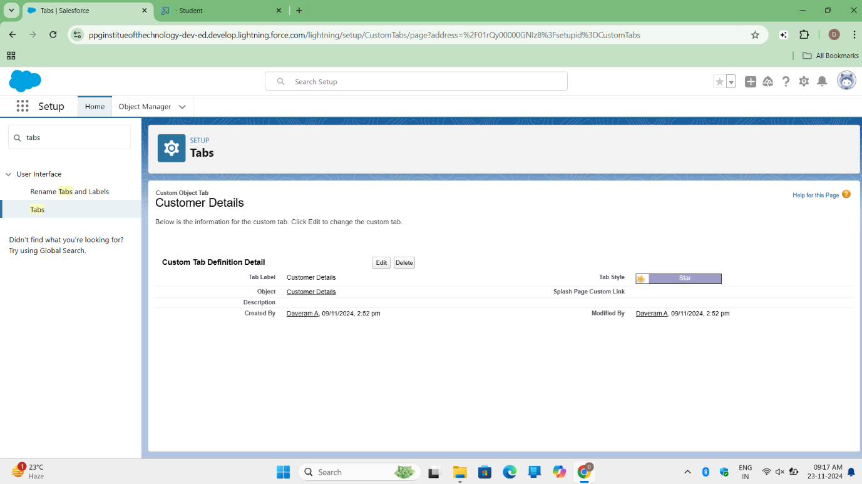

I created a custom tab for the "Customer Details" object by following these steps:

1. In **Setup**, I typed "Tabs" in the Quick Find bar and clicked on **Tabs**.
2. I selected **New** under the Custom Object Tab section and chose the "Customer Details" object.
3. I selected a tab style, then clicked **Next**. For the profile page, I kept the default settings and clicked **Next**. I unchecked the option to include the tab in the Custom App.
4. I ensured the option "Append tab to users' existing personal customizations" was checked, then clicked **Save**.

**Activity 2: Creating Remaining Tabs (Appointments, Service Records, Billing Details and Feedback)**

**Service Records:**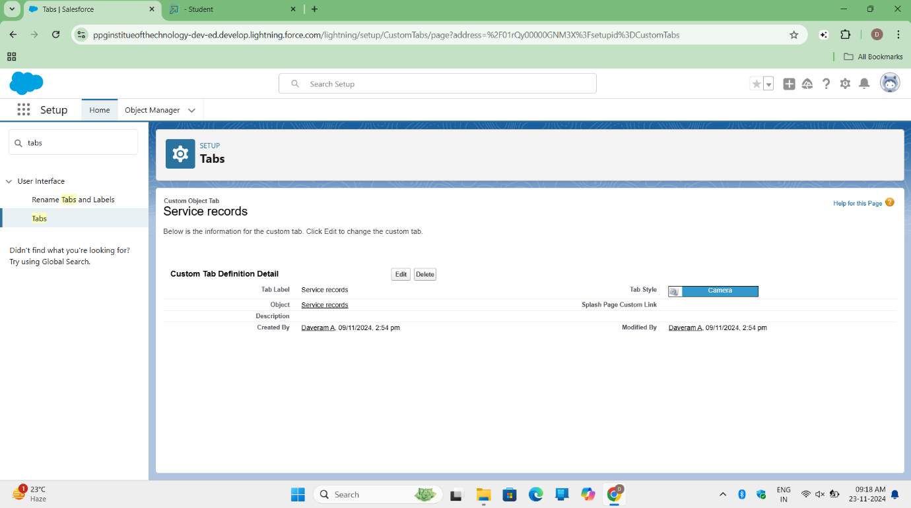

**Billing Details and Feedback:**

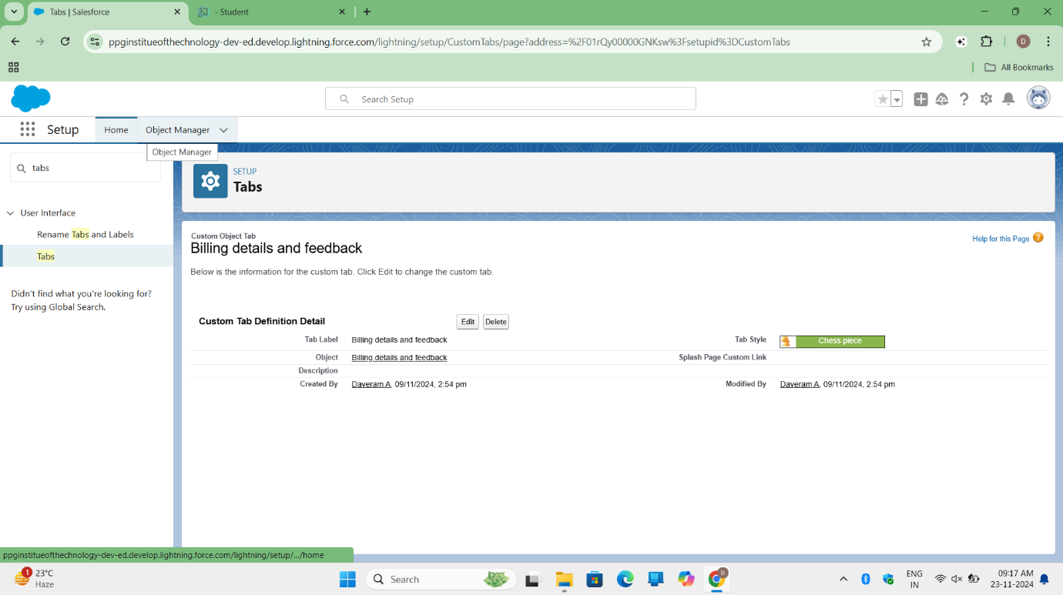

**Appointments:**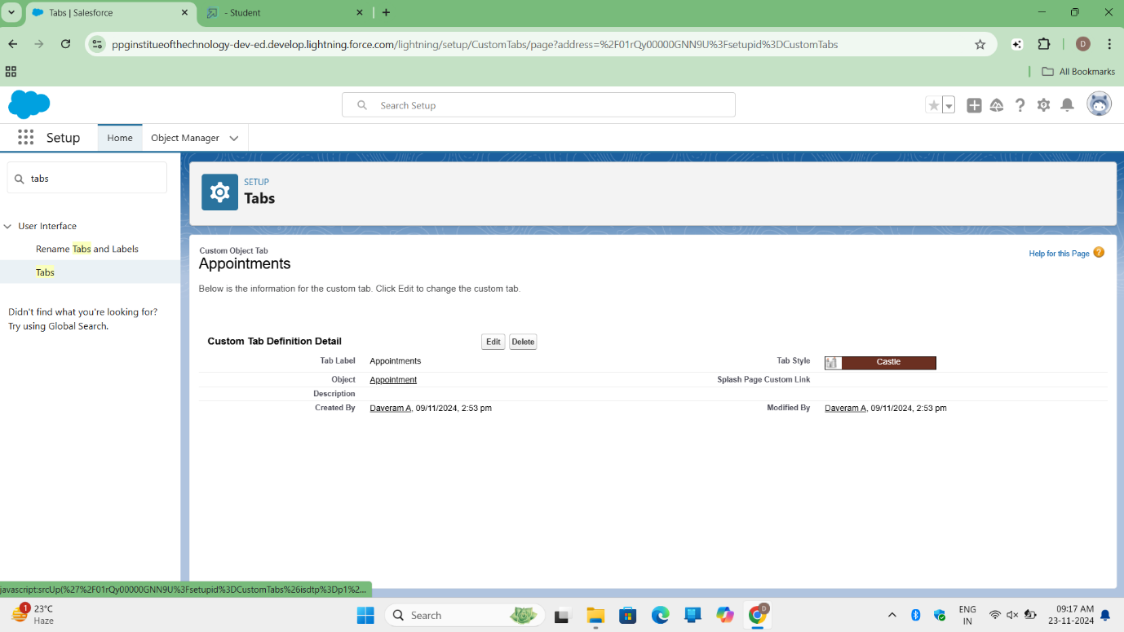

I created custom tabs for the remaining objects ("Appointments," "Service Records," and "Billing Details and Feedback") by following the same steps as in Activity 1:

1. In **Setup**, I typed "Tabs" in the Quick Find bar and clicked on **Tabs**.
2. I selected **New** under the Custom Object Tab section and created tabs for each object:
   * **Appointments**
   * **Service Records**
   * **Billing Details and Feedback**
3. For each tab, I selected a tab style, clicked **Next**, kept the default profile settings, and unchecked the option to include the tab in the Custom App.
4. I made sure the option "Append tab to users' existing personal customizations" was checked for each tab, then clicked **Save**.

**Milestone 4- The Lightning App:**

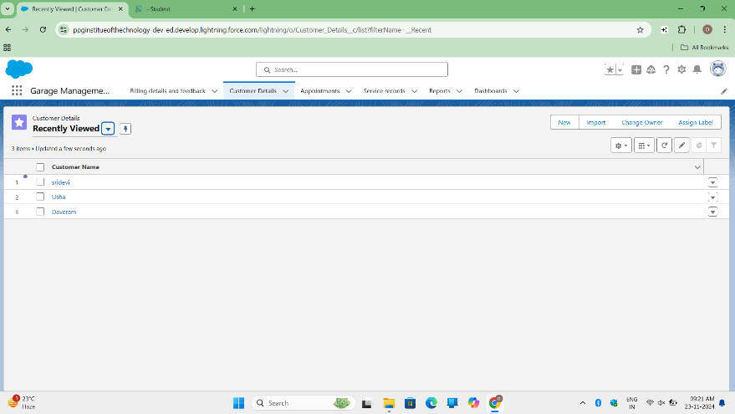**Activity 1: Create a Lightning App**

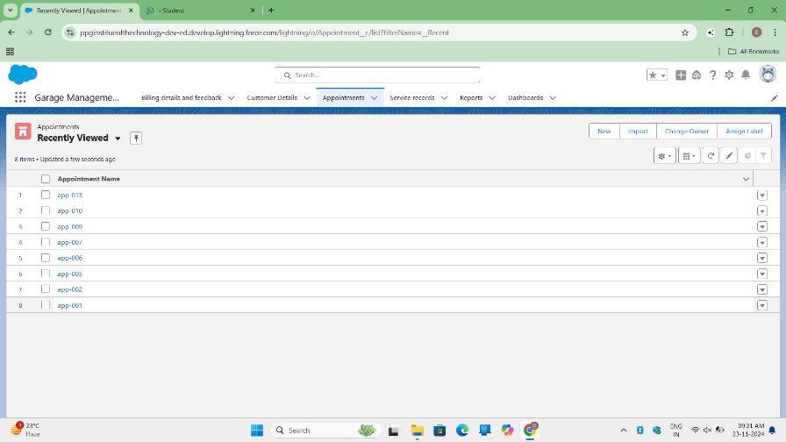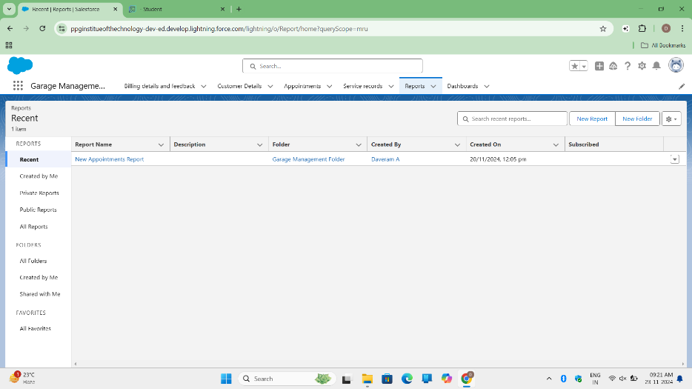

I created a Lightning App named "Garage Management Application" by following these steps:

1. In **Setup**, I searched for **App Manager** in the Quick Find bar and selected **App Manager**, then clicked on **New Lightning App**.
2. In the **App Details** page, I entered the app name as "Garage Management Application" and clicked **Next**. On the **App Options** page, I kept the default settings and clicked **Next**. Similarly, I kept the default settings on the **Utility Items** page and clicked **Next**.
3. To add Navigation Items, I selected "Customer Details," "Appointments," "Service Records," "Billing Details and Feedback," "Reports," and "Dashboards" from the search bar and moved them using the arrow button, then clicked **Next**.
4. In the **User Profiles** section, I searched for the "System Administrator" profile, moved it using the arrow button, and clicked **Save & Finish** to complete the app creation.

**Milestone 5 : Fields**

**Activity 1: Creation of Fields for the Customer Details Object**

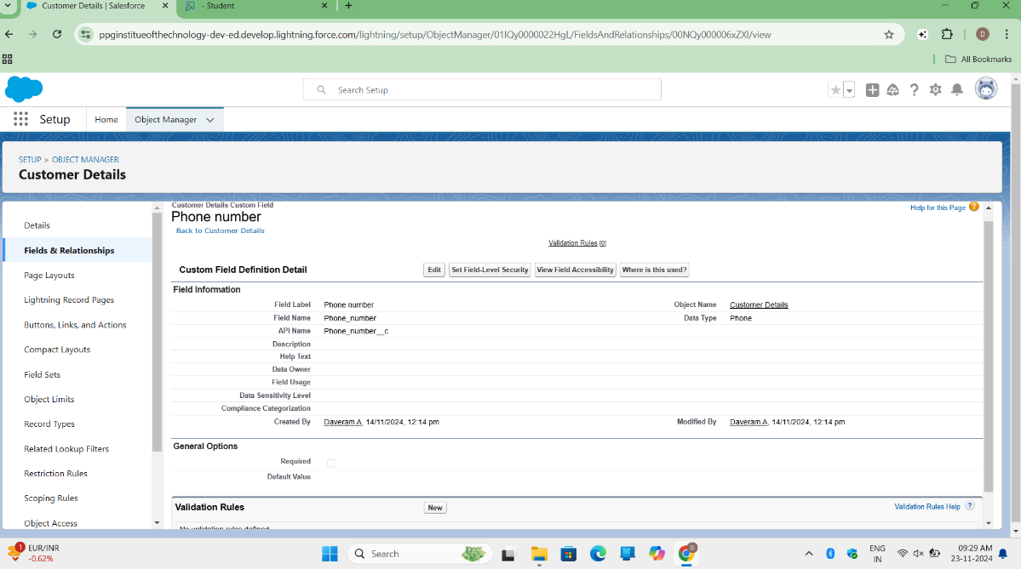

I created a field for the "Customer Details" object by following these steps:

1. In **Setup**, I navigated to **Object Manager**, searched for "Customer Details," and selected the object.
2. Under **Fields & Relationships**, I clicked **New** to create a new field.
3. I selected **Phone** as the data type and clicked **Next**.
4. I filled in the details as follows:
   * **Field Label**: Phone Number
   * **Field Name**: Auto-generated
5. I clicked **Next** to proceed and then clicked **Save and New** to create additional fields.

I followed the same steps to create the remaining fields for the "Customer Details" object.

**Activity 2: Creation of Fields for the Customer Details Object**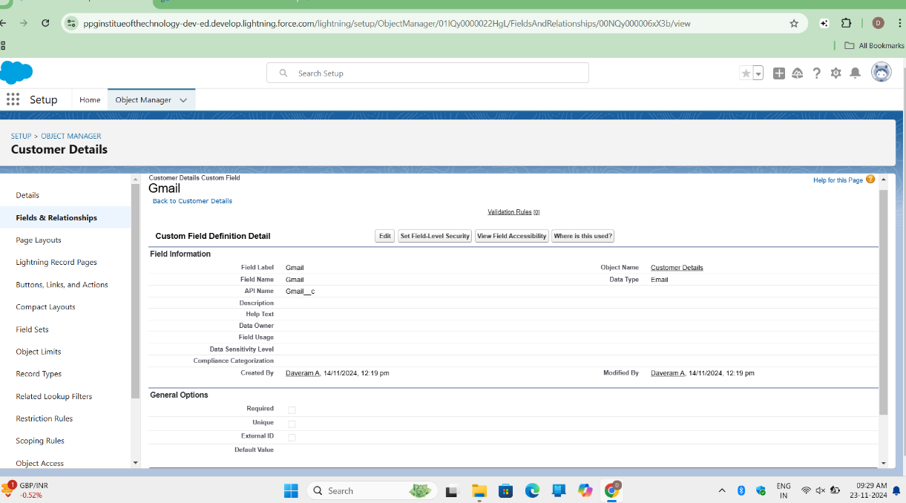

I created another field for the "Customer Details" object by following these steps:

1. In **Setup**, I navigated to **Object Manager**, searched for "Customer Details," and selected the object.
2. Under **Fields & Relationships**, I clicked **New** to create a new field.
3. I selected **Email** as the data type and clicked **Next**.
4. I filled in the details as follows:
   * **Field Label**: Gmail
   * **Field Name**: Auto-generated
5. I clicked **Next** and then **Save and New** to continue creating additional fields.

I repeated this process for other fields needed in the "Customer Details" object.

**Activity 2: Creation of Lookup Fields**

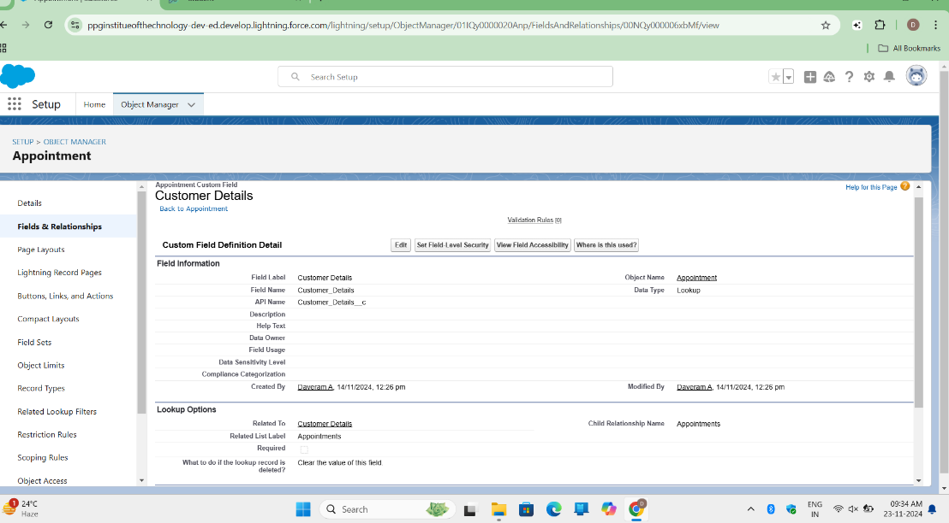

I created a Lookup field on the "Appointment" object by following these steps:1

1. In **Setup**, I navigated to **Object Manager**, searched for "Appointment," and selected the object.
2. Under **Fields & Relationships**, I clicked **New** to create a new field.
3. I selected **Lookup Relationship** as the data type and clicked **Next**.
4. I chose the related object as **Customer Details** and clicked **Next**.
5. I clicked **Next** again and then **Save** to complete the field creation.

(Note: I made sure to complete Activity 4 before continuing with this task.)

**Creation of Lookup Field on Service Records Object**

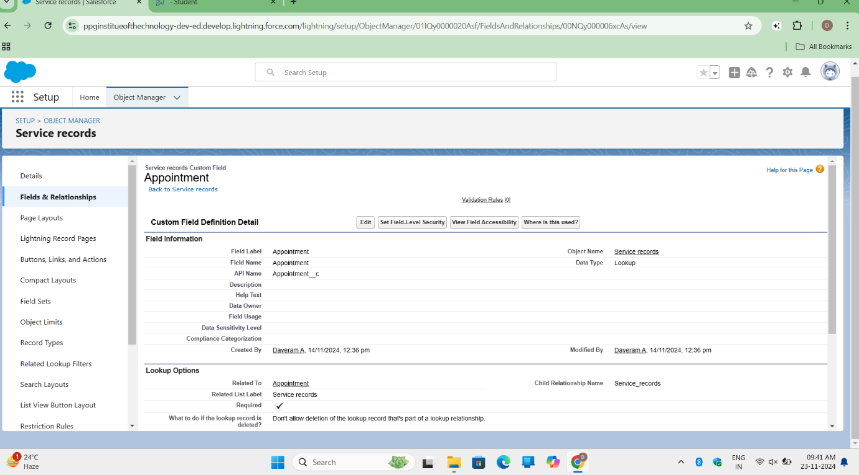

I created a Lookup field on the "Service Records" object by following these steps:

1. In **Setup**, I navigated to **Object Manager**, searched for "Service Records," and selected the object.
2. Under **Fields & Relationships**, I clicked **New** to create a new field.
3. I selected **Lookup Relationship** as the data type and clicked **Next**.
4. I chose the related object as **Appointment** and clicked **Next**.
5. I marked the field as **Required** and clicked **Next**.
6. In the **Lookup Filter** section, I clicked **Show filter settings** and added the filter criteria:
   * **Field**: Appointment: Appointment Date
   * **Operator**: Less than
   * **Select Field**: Appointment: Created Date
   * **Filter Type**: Required
   * **Error Message**: "Value does not match the criteria"
7. I enabled the filter by clicking **Active**.
8. I clicked **Next** and then **Save** to complete the field creation.

**Creation of Lookup Field on Billing Details and Feedback Object**

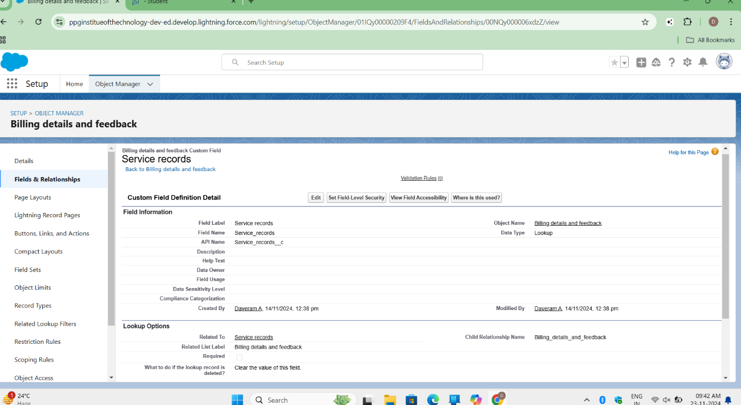

I created a Lookup field on the "Billing Details and Feedback" object by following these steps:

1. In **Setup**, I navigated to **Object Manager**, searched for "Billing Details and Feedback," and selected the object.
2. Under **Fields & Relationships**, I clicked **New** to create a new field.
3. I selected **Lookup Relationship** as the data type and clicked **Next**.
4. I selected the related object as **Service Records** and clicked **Next**.
5. I clicked **Next** again and then **Save & New** to continue creating additional fields.

**Activity 3: Creation of Checkbox Fields**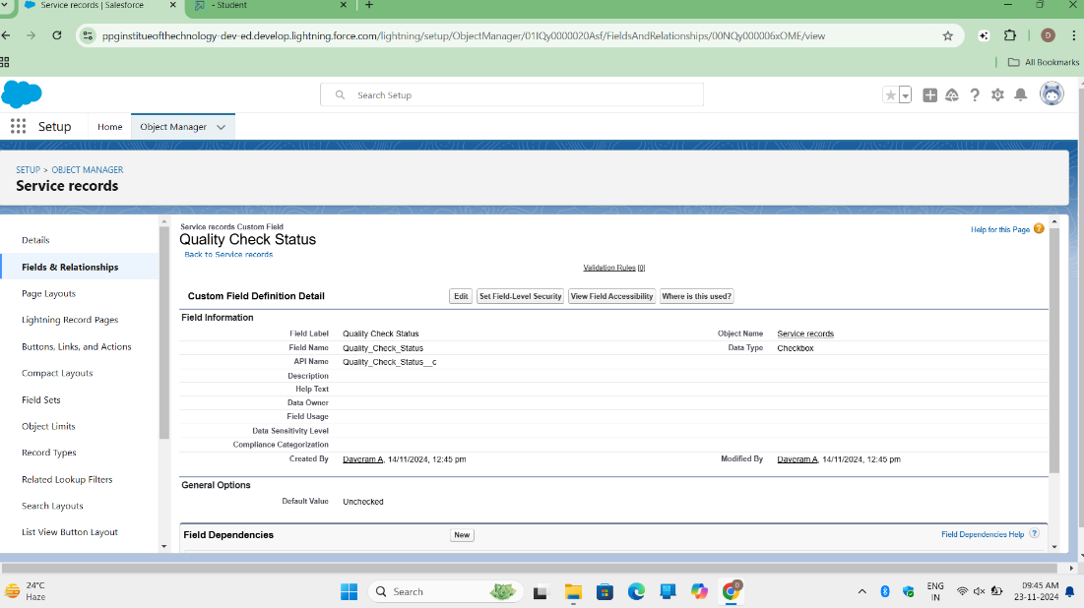

I created a Checkbox field on the "Appointment" object by following these steps:

1. In **Setup**, I navigated to **Object Manager**, searched for "Appointment," and selected the object.
2. Under **Fields & Relationships**, I clicked **New** to create a new field.
3. I selected **Checkbox** as the data type and clicked **Next**.
4. I entered the following details:
   * **Field Label**: Maintenance Service
   * **Field Name**: Auto-populated
   * **Default Value**: Unchecked
5. I clicked **Next** and then **Save** to complete the field creation.

**Creation of Additional Checkbox Fields on Appointment Object**

I created two additional Checkbox fields on the "Appointment" object by following these steps:

1. I repeated the steps from **Activity 3** for the following fields:
   * **Repairs**:

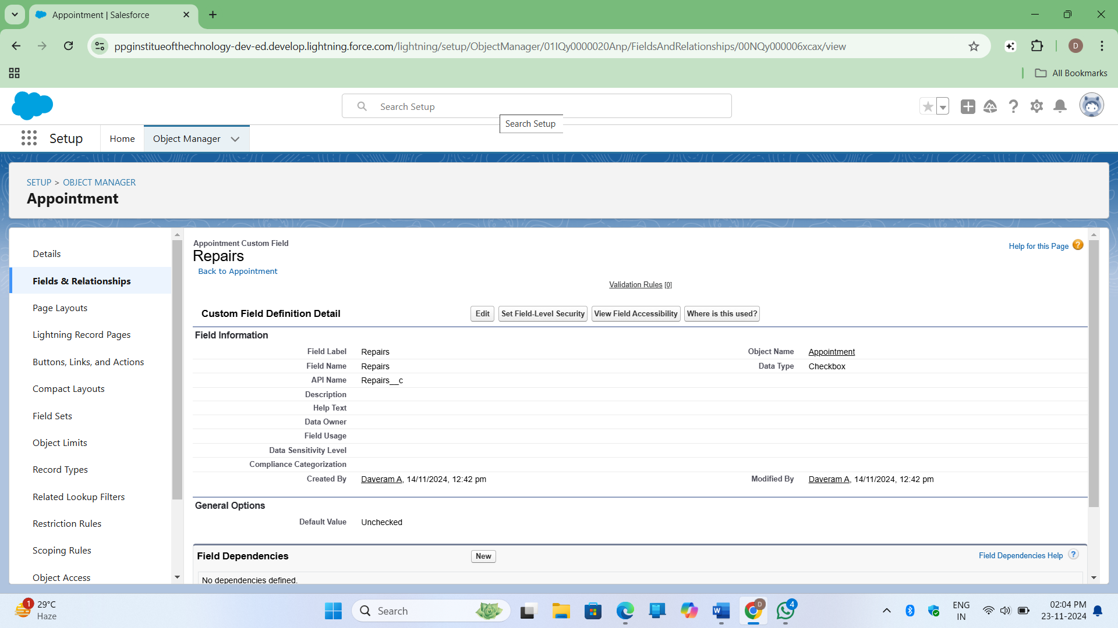

* + - **Field Label**: Repairs
    - **Field Name**: Auto-populated
    - **Default Value**: Unchecked
  + I clicked **Next** and then **Save**.

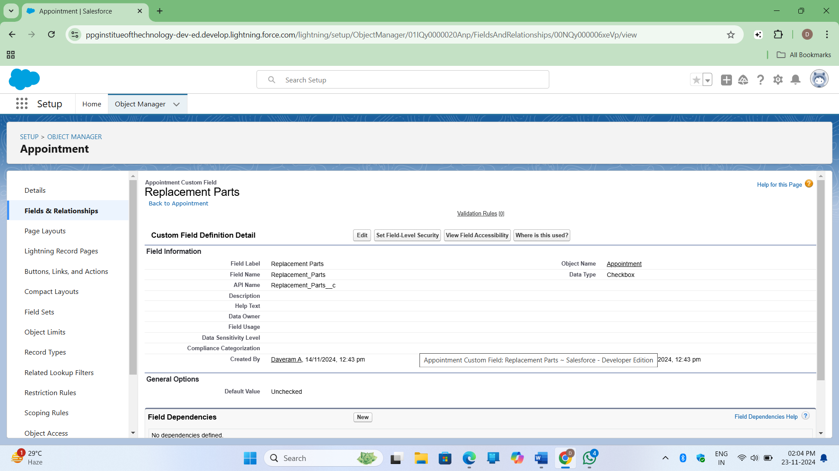

* + **Replacement Parts**:
    - **Field Label**: Replacement Parts
    - **Field Name**: Auto-populated
    - **Default Value**: Unchecked
  + I clicked **Next** and then **Save**.

These steps were followed to create the checkbox fields successfully.

**Creation of Checkbox Field on Service Records Object**

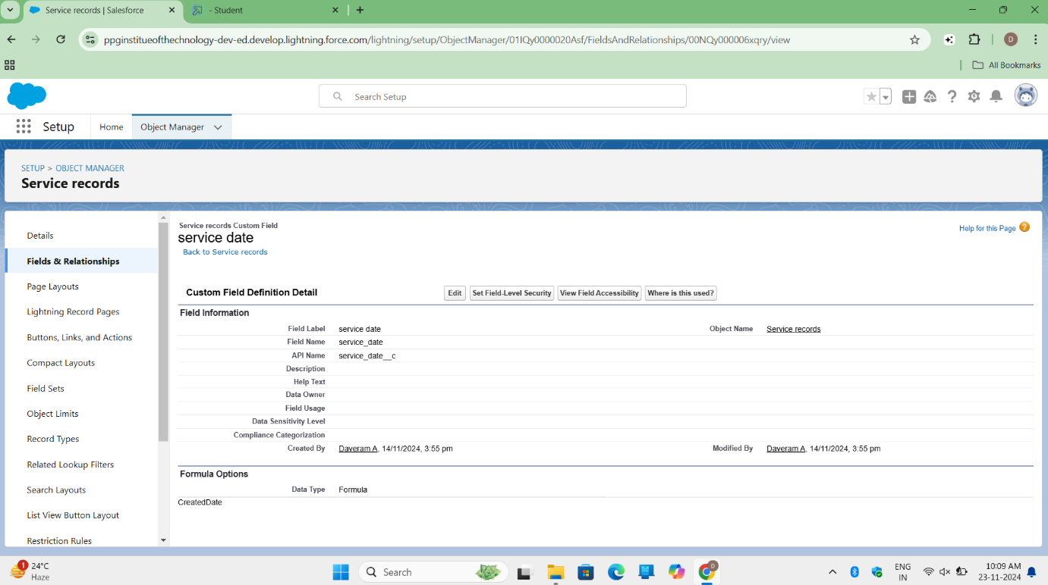

I created a Checkbox field on the "Service Records" object by following these steps:

1. In **Setup**, I navigated to **Object Manager**, searched for "Service Records," and selected the object.
2. Under **Fields & Relationships**, I clicked **New** to create a new field.
3. I selected **Checkbox** as the data type and clicked **Next**.
4. I entered the following details:
   * **Field Label**: Quality Check Status
   * **Field Name**: Auto-populated
   * **Default Value**: Unchecked
5. I clicked **Next** and then **Save** to complete the field creation.

**Activity 4: Creation of Date Fields**

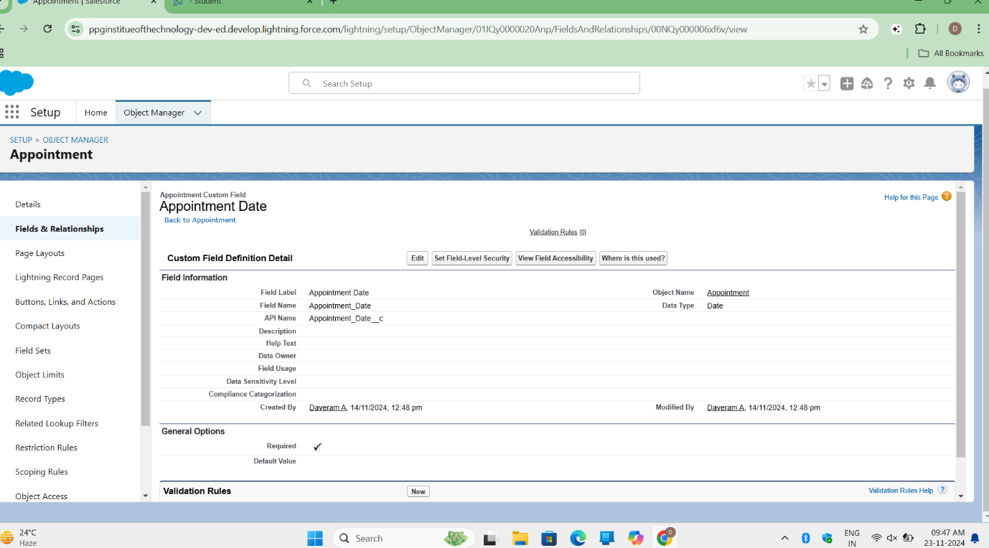

I created a Date field on the "Appointment" object by following these steps:

1. In **Setup**, I navigated to **Object Manager**, searched for "Appointment," and selected the object.
2. Under **Fields & Relationships**, I clicked **New** to create a new field.
3. I selected **Date** as the data type and clicked **Next**.
4. I entered the following details:
   * **Field Label**: Appointment Date
   * **Field Name**: Auto-populated
5. I made the field **Required** by selecting the **Required** option.
6. I clicked **Next** and then **Save** to complete the field creation.

**Activity 5: Creation of Currency Fields**

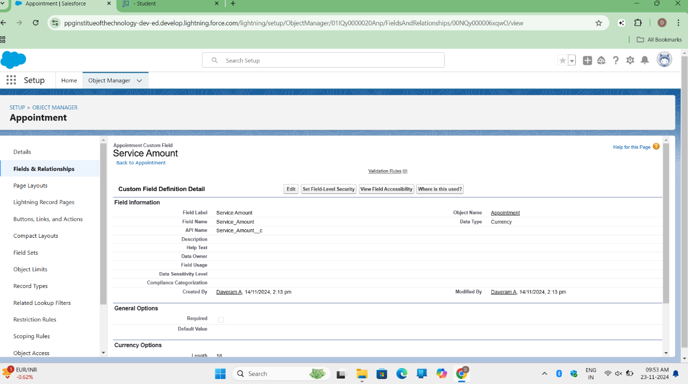

I created a Currency field on the "Appointment" object by following these steps:

1. In **Setup**, I navigated to **Object Manager**, searched for "Appointment," and selected the object.
2. Under **Fields & Relationships**, I clicked **New** to create a new field.
3. I selected **Currency** as the data type and clicked **Next**.
4. I entered the following details:
   * **Field Label**: Service Amount
   * **Field Name**: Auto-populated
5. I clicked **Next**.
6. In the **Field-Level Security** settings, I marked the field as **Read-Only** for all profiles.
7. I clicked **Next** and then **Save** to complete the field creation.

**Creation of Currency Field on Billing Details and Feedback Object**

I created a Currency field on the "Billing Details and Feedback" object by following these steps: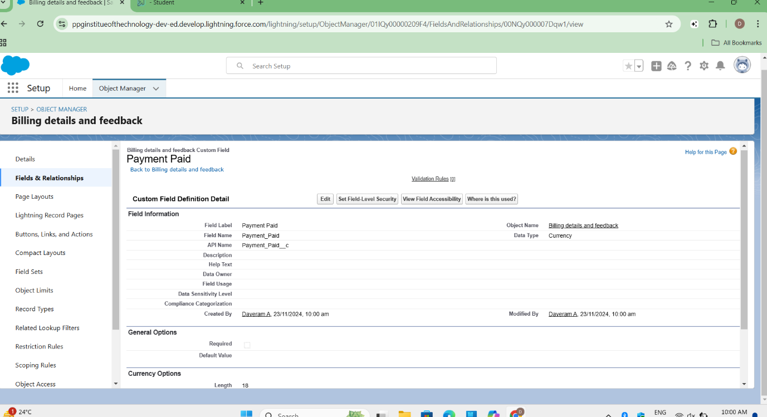

1. I followed the same steps as in the previous activity for the "Appointment" object, but this time for the "Billing Details and Feedback" object.
2. I entered the following details:
   * **Field Label**: Payment Paid
   * **Field Name**: Auto-populated
3. I clicked **Next**, then configured the **Field-Level Security** as **Read-Only** for all profiles.
4. Finally, I clicked **Next** and **Save** to complete the field creation.

**Activity 6: Creation of Text Fields**

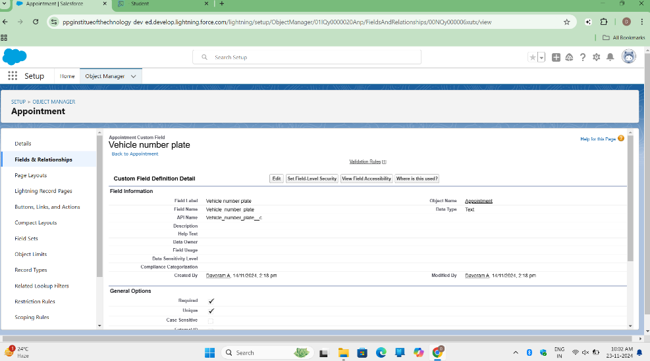

I created a Text field on the "Appointment" object by following these steps:

1. In **Setup**, I navigated to **Object Manager**, searched for "Appointment," and selected the object.
2. Under **Fields & Relationships**, I clicked **New** to create a new field.
3. I selected **Text** as the data type and clicked **Next**.
4. I entered the following details:
   * **Field Label**: Vehicle Number Plate
   * **Field Name**: Auto-populated
   * **Length**: 10
5. I made the field **Required** and **Unique**.
6. I clicked **Next**, then **Save** to complete the field creation.

**Creation of Text Fields in Billing Details and Feedback Object**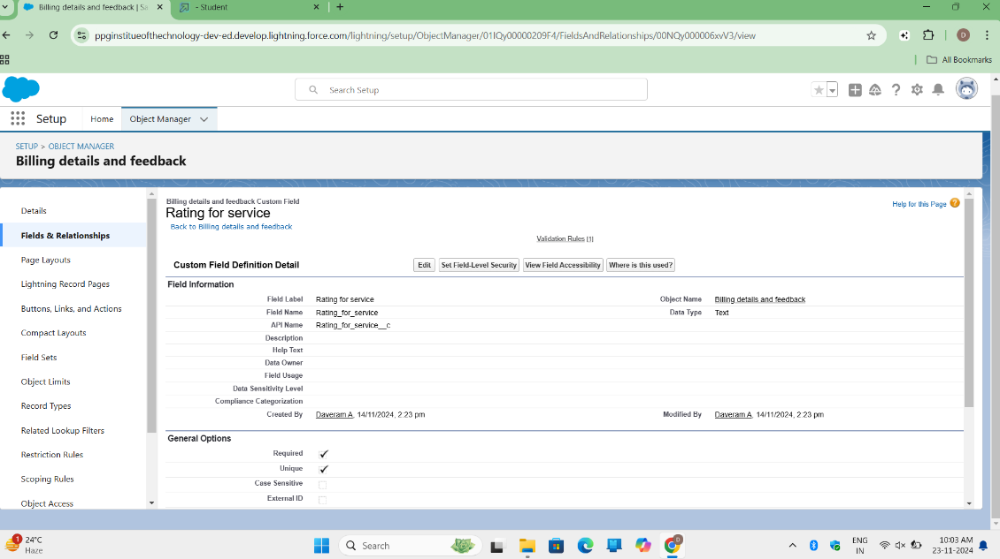

I created a Text field on the "Billing Details and Feedback" object by following these steps:

1. In **Setup**, I navigated to **Object Manager**, searched for "Billing Details and Feedback," and selected the object.
2. Under **Fields & Relationships**, I clicked **New** to create a new field.
3. I selected **Text** as the data type and clicked **Next**.
4. I entered the following details:
   * **Field Label**: Rating for Service
   * **Field Name**: Auto-populated
   * **Length**: 1
5. I made the field **Required**.
6. I clicked **Next**, then **Save** to complete the field creation.

**Milestone 6: Validation Rule**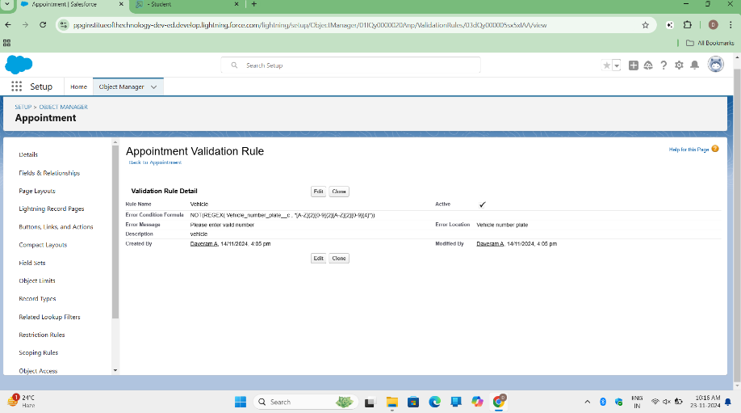

**Activity 1: Create Validation Rule on Appointment Object**  
I created a validation rule on the Appointment object by following these steps:

1. From the setup page, I clicked on **Object Manager** and edited the Appointment object.
2. Under **Validation Rules**, I clicked **New**.
3. I entered the rule name as **Vehicle**.
4. The error condition formula I used was:
5. **NOT(REGEX(Vehicle_number_plate__c, "[A-Z]{2}[0-9]{2}[A-Z]{2}[0-9]{4}"))**
6. I entered the error message as **"Please enter a valid number"**, selected **Field** as the error location, and chose the **Vehicle Number Plate** field.
7. I clicked **Save**.

**Activity 2: Create Validation Rule on Billing Details and Feedback Object**

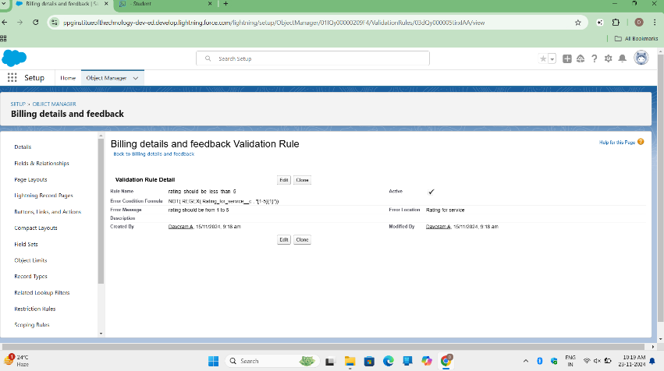  
I created a validation rule on the Billing Details and Feedback object by following these steps:

1. From the setup page, I edited the **Billing Details and Feedback** object.
2. I clicked on **Validation Rules** and then **New**.
3. I named the rule **rating_should_be_less_than_5**.
4. The error condition formula I used was:
5. **NOT(REGEX(Rating_for_service__c, "[1-5]{1}"))**
6. I set the error message as **"Rating should be from 1 to 5"**, selected **Field** for the error location, and chose **Rating for Service** field.
7. I clicked **Save**.

**Milestone 7: Duplicate Rule**

**Activity 1: Create Matching Rule on Customer Details Object**

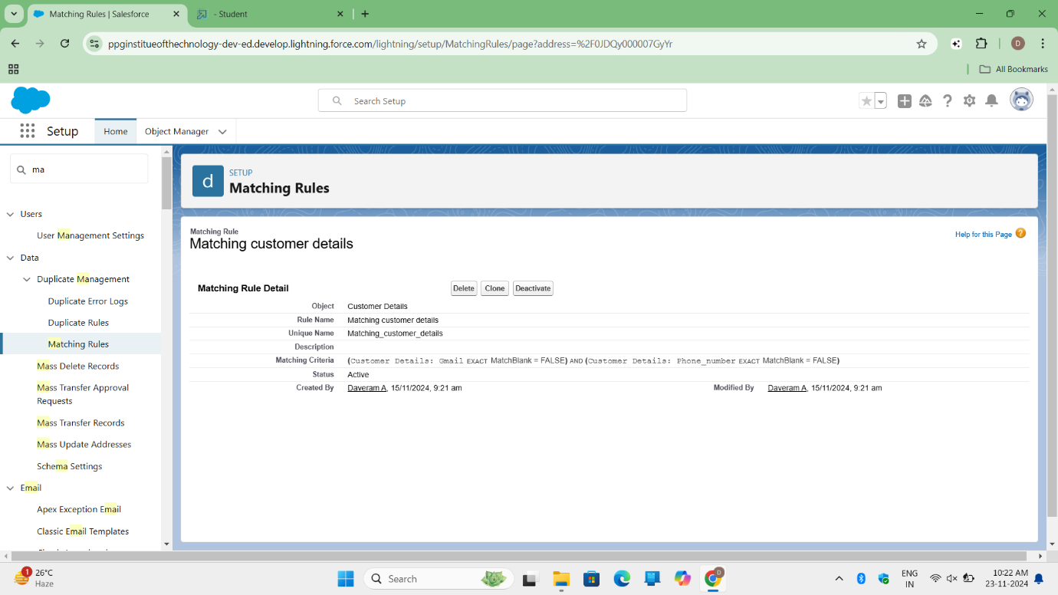  
I created a matching rule on the **Customer Details** object by following these steps:

1. I searched for **Matching Rule** in the Quick Find box.
2. I clicked on **Matching Rule** and then clicked **New Rule**.
3. I selected the **Customer Details** object and clicked **Next**.
4. I named the rule **Matching customer details**.
5. The unique name was auto-populated.
6. I defined the matching criteria as:
   * **Gmail**: Exact
   * **Phone Number**: Exact
7. I clicked **Save** and then **Activate**.

**Activity 2: Create Duplicate Rule on Customer Details Object**

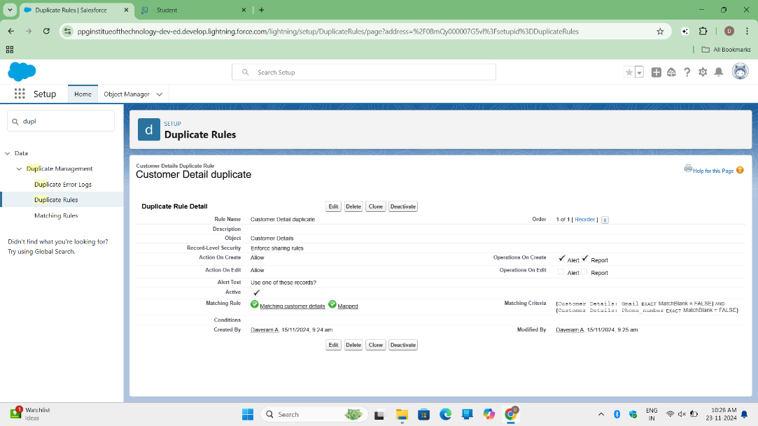  
I created a duplicate rule on the **Customer Details** object by following these steps:

1. I searched for **Duplicate Rules** in the Quick Find box.
2. I clicked on **Duplicate Rule** and then clicked **New Rule**.
3. I selected the **Customer Details** object.
4. I named the rule **Customer Detail Duplicate**.
5. I selected the **Matching customer details** rule in the matching rule section.
6. I clicked **Save** and then **Activate**.

**Milestone 8: Profiles**

**Activity 1: Manager Profile**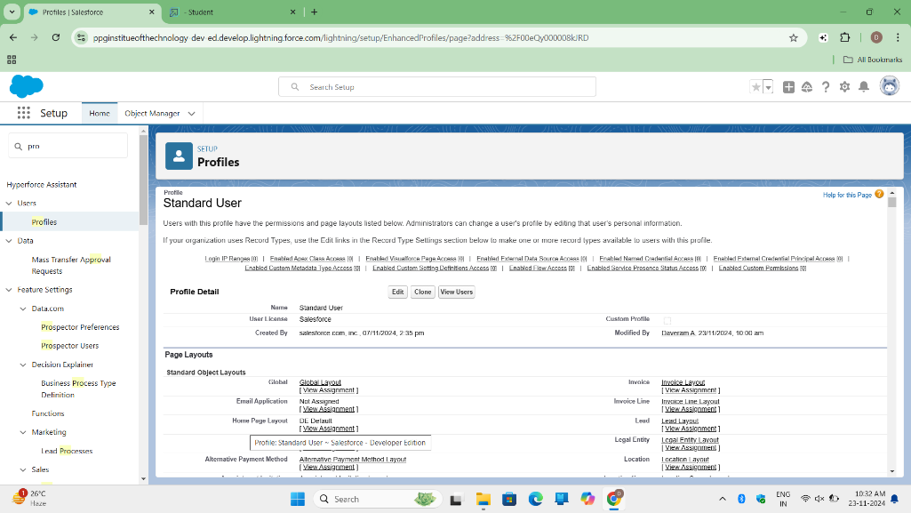  
I created a new profile for the **Manager** by following these steps:

1. From the setup page, I searched for **Profiles** in the Quick Find box and clicked on **Profiles**.
2. I cloned the **Standard User** profile and named the new profile **Manager**, then clicked **Save**.
3. I clicked **Edit** to modify the profile.
4. Under **Custom App Settings**, I set the default app as **Garage Management**.
5. I scrolled down to **Custom Object Permissions** and provided access for the following objects:
   * **Appointments**
   * **Billing Details and Feedback**
   * **Service Records**
   * **Customer Details**
6. I set the session timeout to **8 hours of inactivity**.
7. I updated the password policies as follows:
   * **User passwords expire in**: Never expires
   * **Minimum password length**: 8
8. I clicked **Save**.

**Activity 2: Sales Person Profile**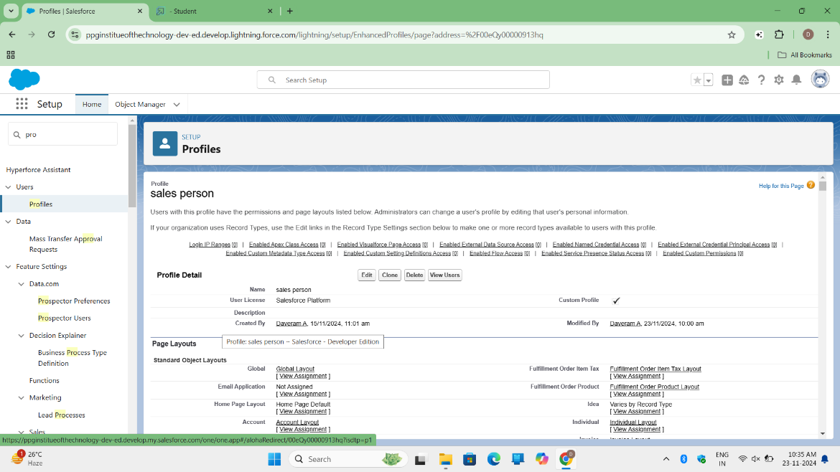  
I created a new profile for the **Sales Person** by following these steps:

1. From the setup page, I searched for **Profiles** in the Quick Find box and clicked on **Profiles**.
2. I cloned the **Salesforce Platform User** profile and named the new profile **Sales Person**, then clicked **Save**.
3. I clicked **Edit** to modify the profile.
4. Under **Custom App Settings**, I set the default app as **Garage Management**.
5. I scrolled down to **Custom Object Permissions** and provided access for the following objects:
   * **Appointments**
   * **Billing Details and Feedback**
   * **Service Records**
   * **Customer Details**
6. I clicked **Save**.

**Milestone 9: Role & Role Hierarchy**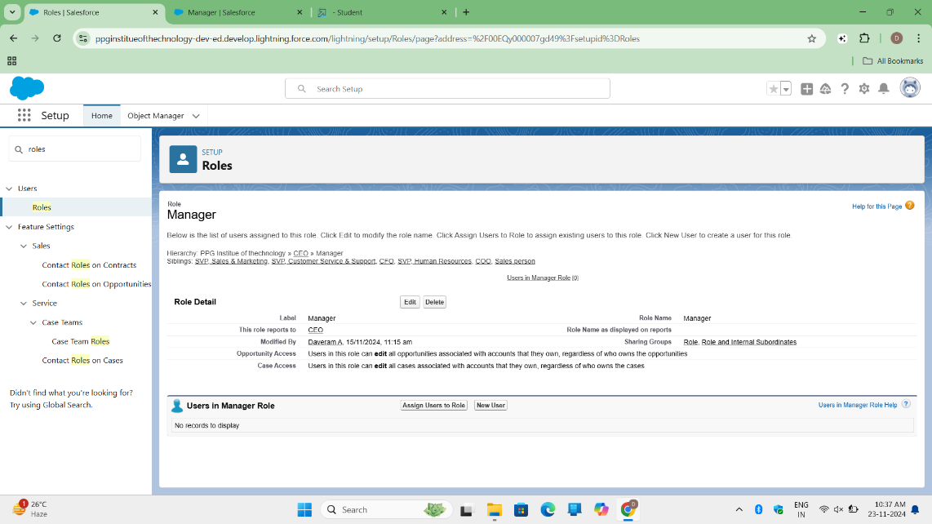

**Activity 1: Creating Manager Role**  
I created the **Manager** role by following these steps:

1. From the Quick Find box, I searched for **Roles** and clicked on **Setup Roles**.
2. I clicked **Expand All** and then clicked **Add Role** under the role the new role works for.
3. I entered **Manager** as the label, and the role name was auto-populated.
4. I clicked **Save**.

**Activity 2: Creating Sales Person Role**

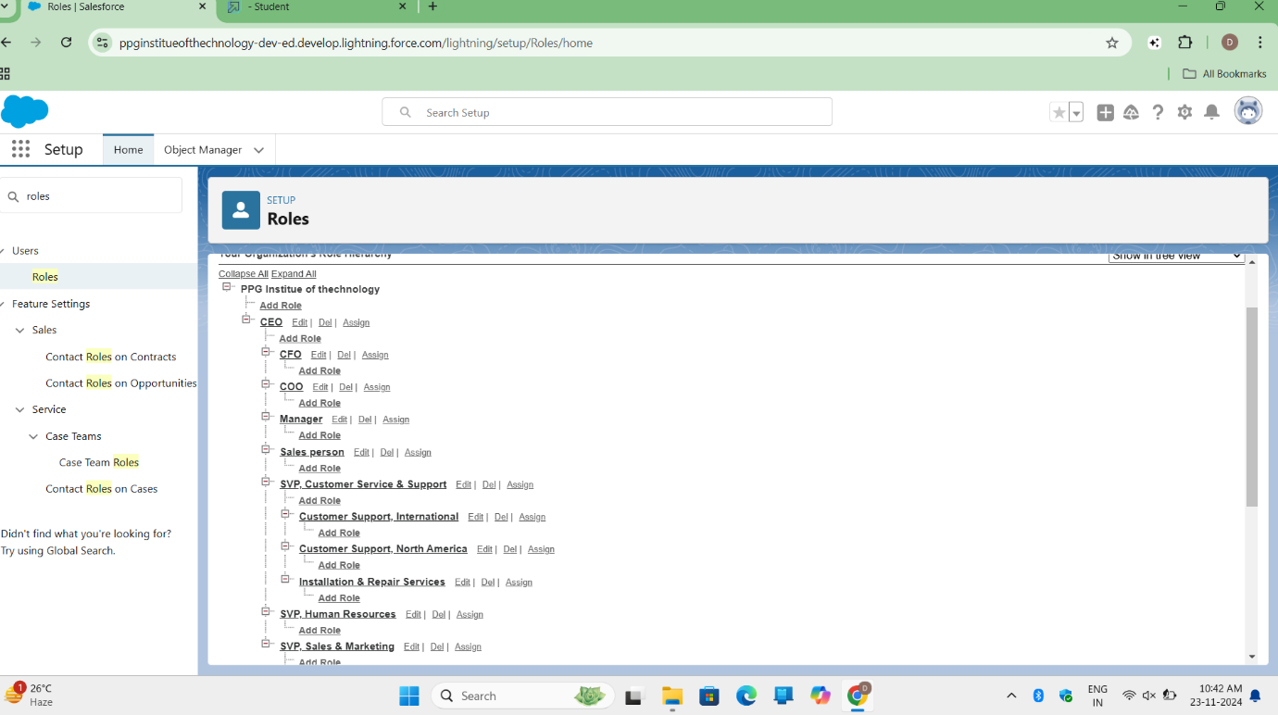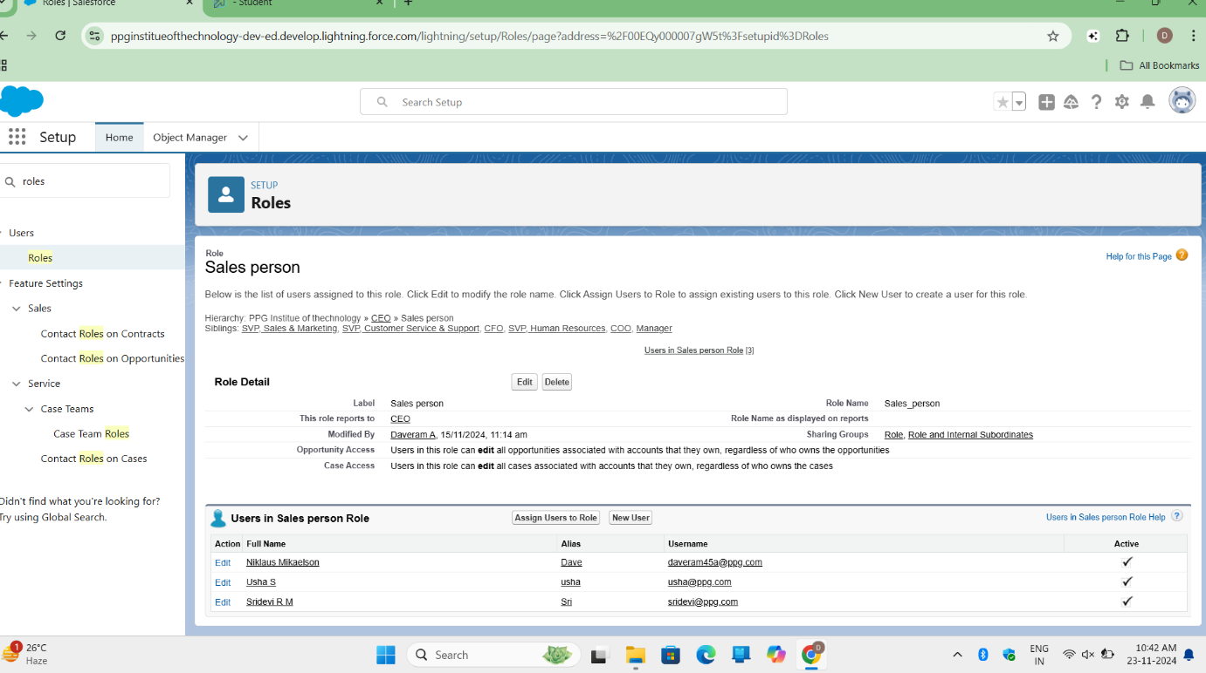  
I created the **Sales Person** role under the **Manager** role by following these steps:

1. From the Quick Find box, I searched for **Roles** and clicked on **Setup Roles**.
2. I clicked the plus sign on the **CEO** role and then clicked **Add Role** under **Manager**.
3. I entered **Sales Person** as the label, and the role name was auto-populated.
4. I clicked **Save**.

**Milestone 10: Users**

**Activity 1: Create User**

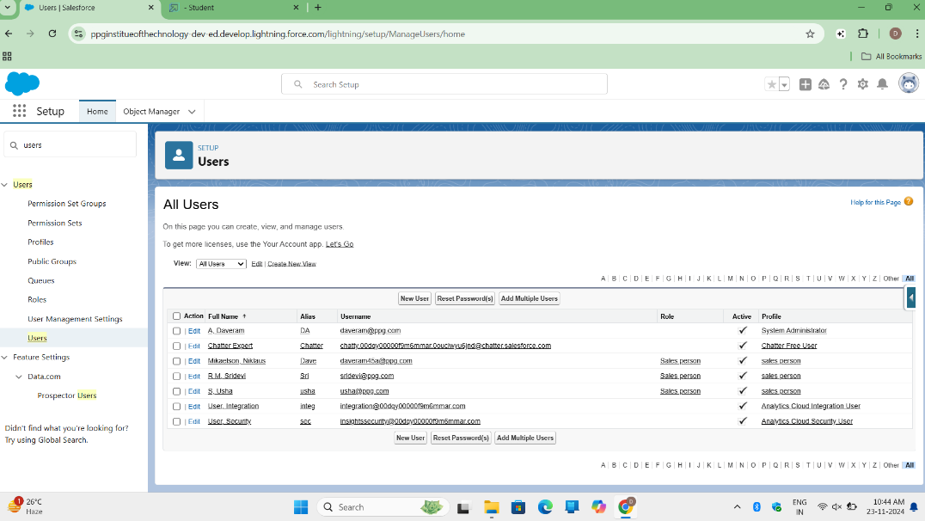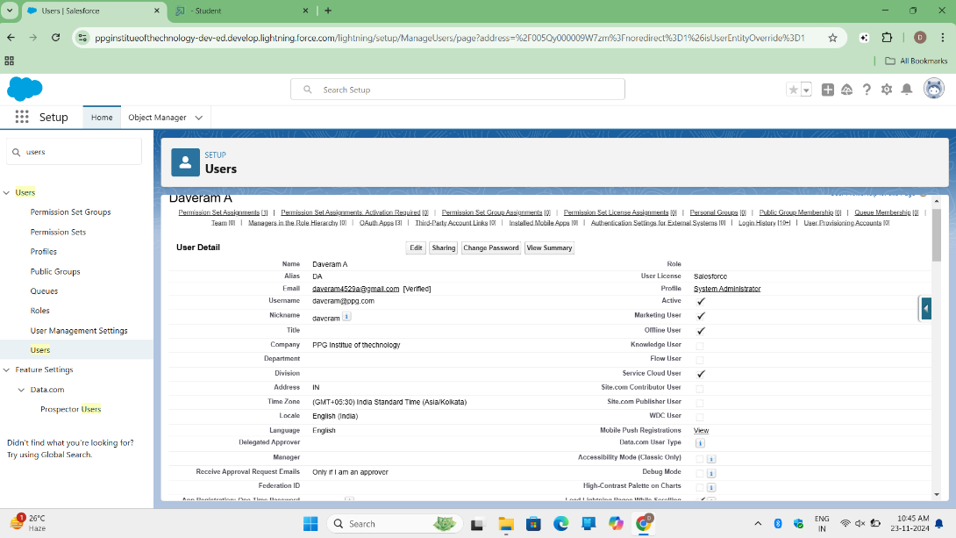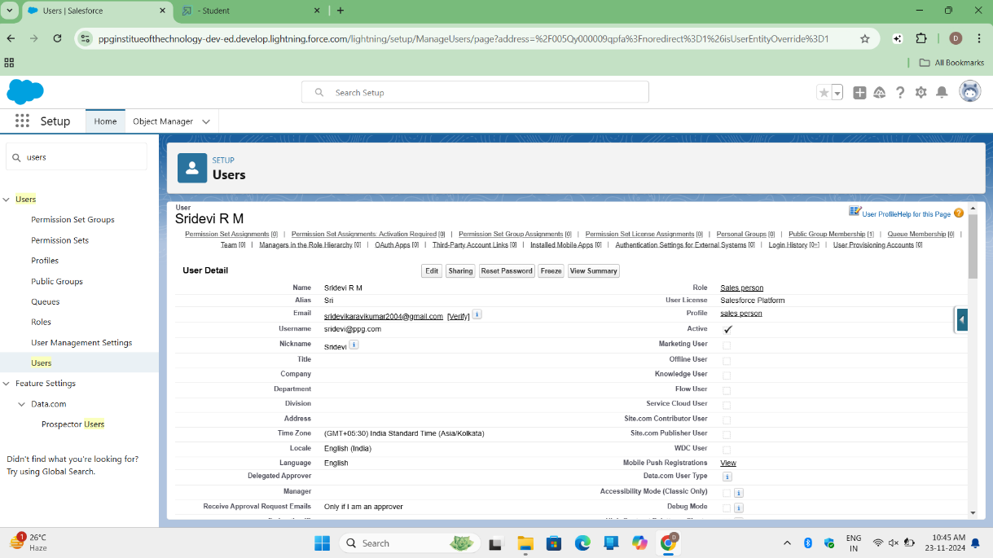  
I created a new user with the following details:

1. From the setup page, I searched for **Users** in the Quick Find box and selected **Users**.
2. I clicked **New User**.
3. I filled in the following fields:
   * **First Name**: Niklaus
   * **Last Name**: Mikaelson
   * **Alias**: (entered alias name)
   * **Email**: (entered personal email ID)
   * **Username**: (used [alise@](mailto:alise@).txt format)
   * **Nickname**: (entered nickname)
   * **Role**: Manager
   * **User License**: Salesforce
   * **Profile**: Manager
4. I clicked **Save**.

**Activity 2: Creating Another User**

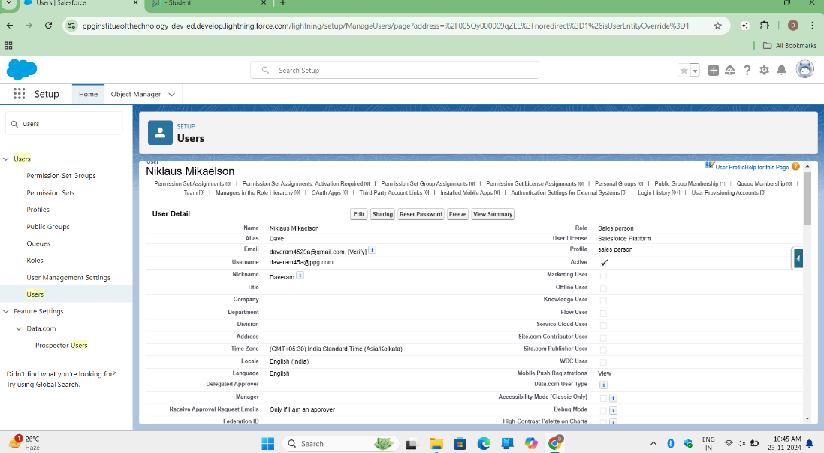  
I repeated the above steps to create another user with the following details:

* **Role**: Sales Person
* **User License**: Salesforce Platform
* **Profile**: Sales Person

I created at least 3 users with the specified permissions.

**Milestone 11: Public Groups.**

**Activity 1: Creating New Public Group**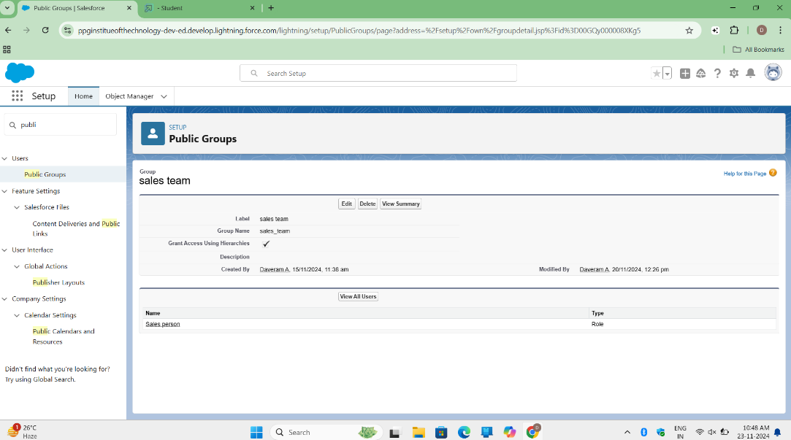  
I created a new public group for the **Sales Team** by following these steps:

1. From the setup page, I searched for **Public Groups** in the Quick Find box and selected **Public Groups**.
2. I clicked **New** to create a new group.
3. I gave the **Label** as **Sales Team** (group name auto-populated).
4. I searched for **Roles** and selected **Sales Person** from the Available Members.
5. I clicked **Add** to move **Sales Person** to Selected Members.
6. I clicked **Save**.

**Milestone 12: Sharing Settings**

**Activity 1: Creating Sharing Settings**

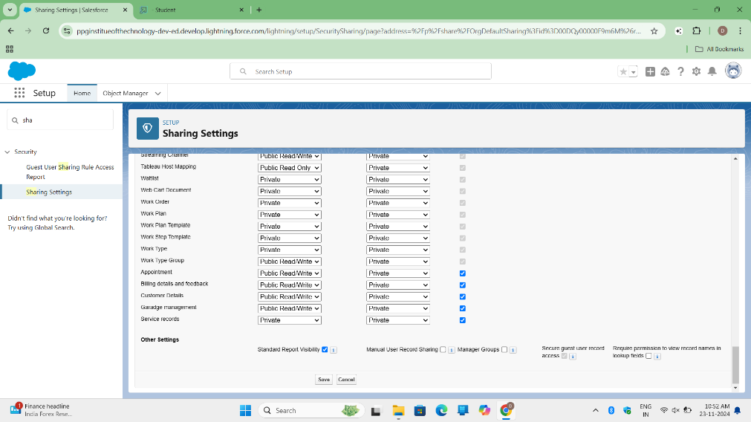  
I configured the sharing settings for the **Service Records** object as follows:

1. From the setup page, I searched for **Sharing Settings** in the Quick Find box and selected **Sharing Settings**.
2. I clicked **Edit**.
3. I changed the **OWD setting** of the **Service Records** object to **Private**.
4. I clicked **Save** and refreshed the page.
5. I scrolled down, clicked **New** under **Service Records Sharing Rules**.
6. I gave the **Label Name** as **Sharing Setting** (rule name auto-populated).
7. In step 3, I selected **Members of Roles** → **Sales Person**.
8. In step 4, I selected **Roles** → **Manager** to share with.
9. In step 5, I set the **Access Level** to **Read/Write**.
10. I clicked **Save**.

**Milestone 13: Flows**

**Activity 1: Create a Flow**

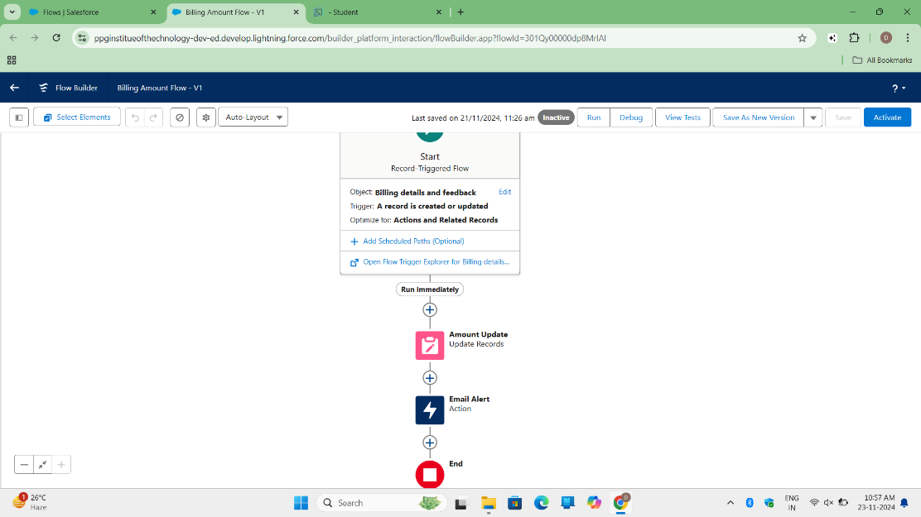

1. Go to **Setup**, type **Flow** in the Quick Find box, and click on **Flow**.
2. Click **New Flow** and select **Record-triggered Flow**, then click **Create**.
3. In the **Object** dropdown, select **Billing Details and Feedback**.
4. Select **Trigger Flow When**: "A record is Created or Updated".
5. Choose **Optimize the Flow for**: "Actions and Related Records", then click **Done**.
6. Under the **Record-triggered Flow**, click the **+** symbol and select **Update Records Element**.
7. Set the **Label Name** as "Amount Update" (API Name will be auto-populated).
8. Set the filter condition: **All Conditions Are Met (AND)**
   * **Field**: Payment_Status__c
   * **Operator**: Equals
   * **Value**: Completed
9. Set the field values for the **Billing Details and Feedback** record:
   * **Field**: Payment_Paid__c
   * **Value**: {!$Record.Service_records__r.Appointment__r.Service_Amount__c}
10. Click **Done**.
11. Create a new resource by selecting **New Resource** from the toolbox.
12. Choose **Resource Type**: **Variable**, then select **Text Template**.
13. Enter **API Name** as alert.
14. Change the **View** to **Plain Text**, then paste the following syntax in the body field:

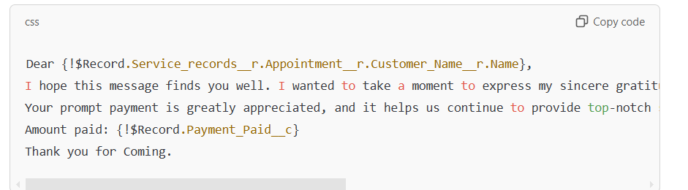

1. Click **Done**.
2. Click **Add Element**, select **Action**, and search for **Send Email**.
3. Give the **Label Name** as "Email Alert". The **API Name** will auto-populate.
4. Enable the body in **Set Input Values for the Selected Action**.
5. Select the **Text Template** created:

* **Body**: {!alert}
* **RecipientAddressList**: {!$Record.Service_records__r.Appointment__r.Customer_Name__r.Gmail__c}

1. Set the **Subject** as "Thank You for Your Payment - Garage Management".
2. Click **Done**.
3. Click **Save**, enter the **Flow Label** (API Name auto-populates), then click **Save** and **Activate**.

**Activity 2: Create Another Flow**

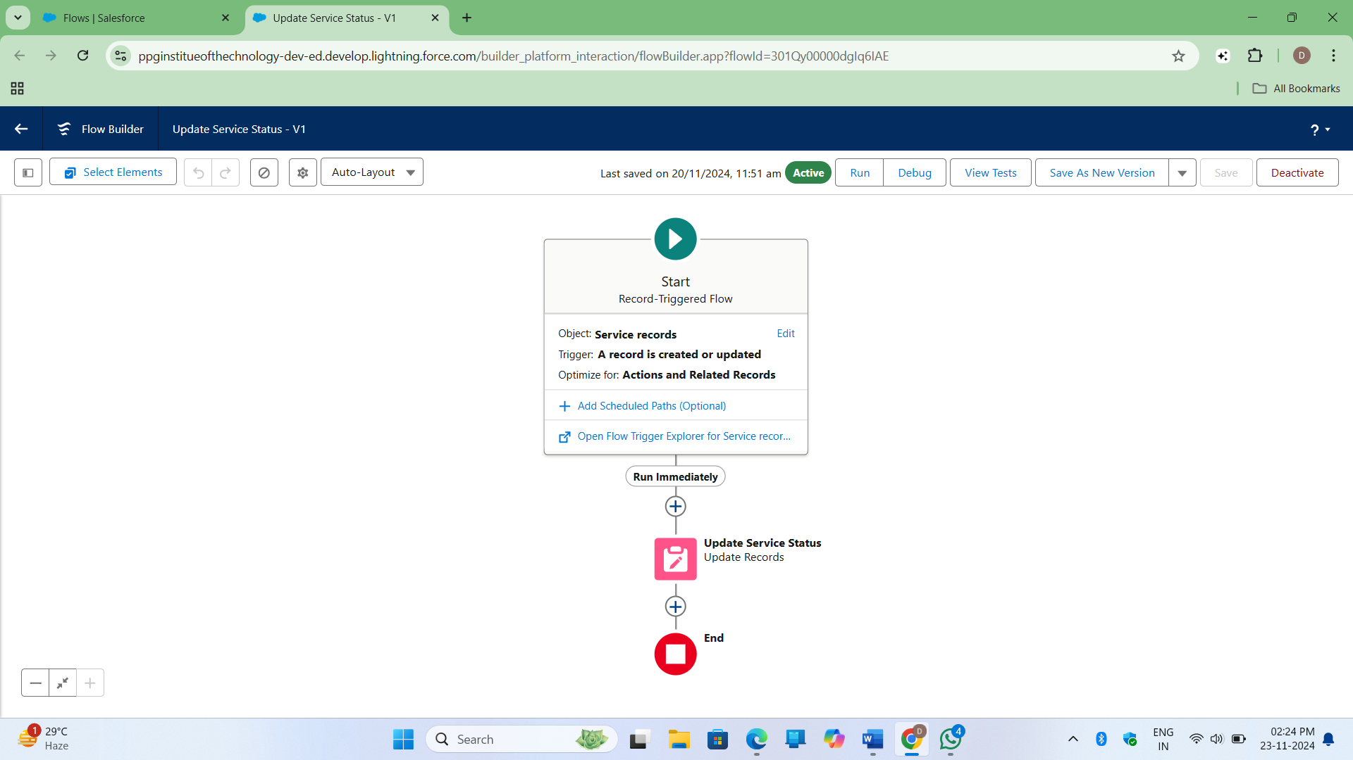

1. Go to **Setup**, type **Flow** in the Quick Find box, and click on **Flow**.
2. Click **New Flow** and select **Record-triggered Flow**, then click **Create**.
3. In the **Object** dropdown, select **Service Records**.
4. Select **Trigger Flow When**: "A record is Created or Updated".
5. Choose **Optimize the Flow for**: "Actions and Related Records", then click **Done**.
6. Under the **Record-triggered Flow**, click the **+** symbol and select **Update Records Element**.
7. Set the filter condition: **All Conditions Are Met (AND)**
   * **Field**: Quality_Check_Status__c
   * **Operator**: Equals
   * **Value**: True
8. Set the field values for the **Service Records** record:
   * **Field**: Service_Status__c
   * **Value**: Completed
9. Click **Done**.
10. Click **Save**, give the **Flow Label** as "Update Service Status" (API Name will be auto-populated).
11. Click **Save** and **Activate**.

Both flows are now created and activated for automating the processes related to the **Billing Details and Feedback** and **Service Records** objects.

Here’s a trimmed version of the content that highlights your work on creating the Apex trigger and handler:

**Milestone 14: Apex Trigger**

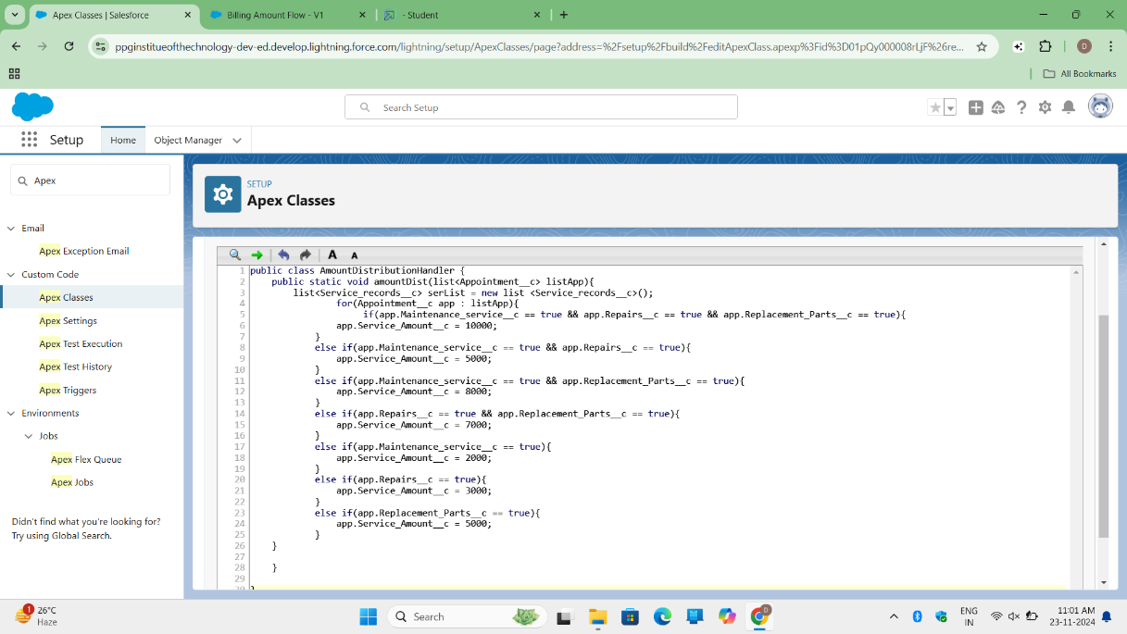

For this milestone, I created an **Apex Trigger** and **Handler** to automate the calculation of service amounts based on the selected services for an appointment.

* The **Apex Handler** (AmountDistributionHandler) is responsible for calculating the service amount based on the combination of services selected, such as maintenance, repairs, and replacement parts. The handler checks different conditions to determine the appropriate service amount and updates the Service_Amount__c field accordingly.

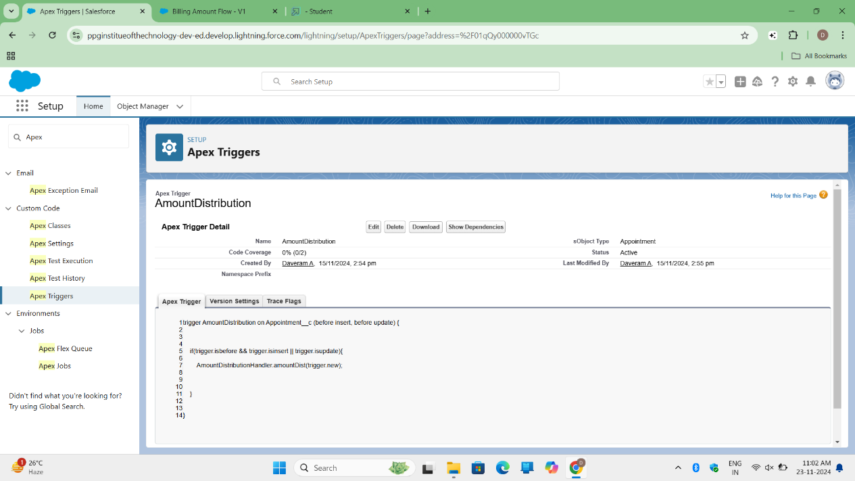

* The **Apex Trigger** (AmountDistribution) was created to execute the handler whenever a new **Appointment** record is inserted or updated. This ensures that the service amount is updated in real-time based on the selected services.

These automated processes help streamline the workflow for updating service amounts in the system, improving accuracy and efficiency.

**Milestone 15: User Adoption**

* **Activity 1: Creating Records** 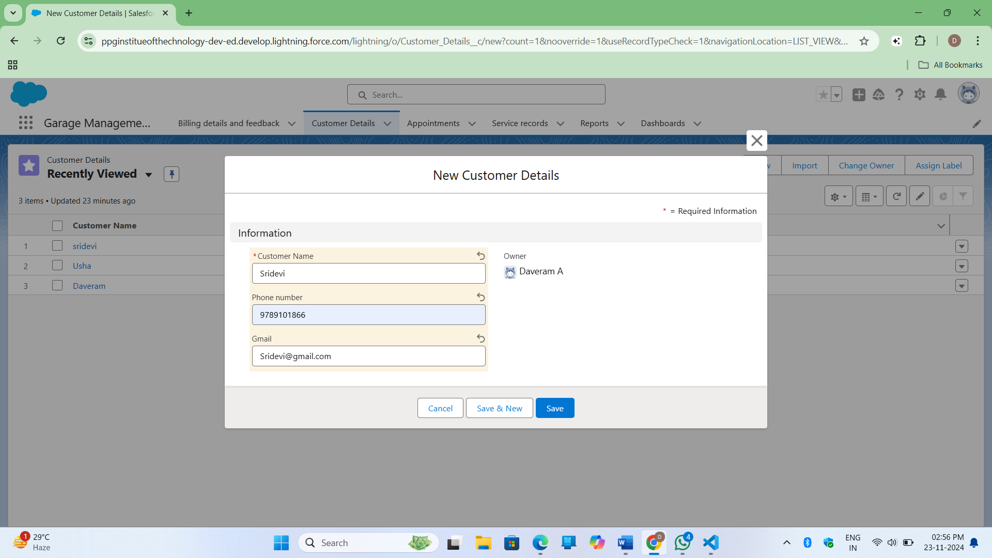
* 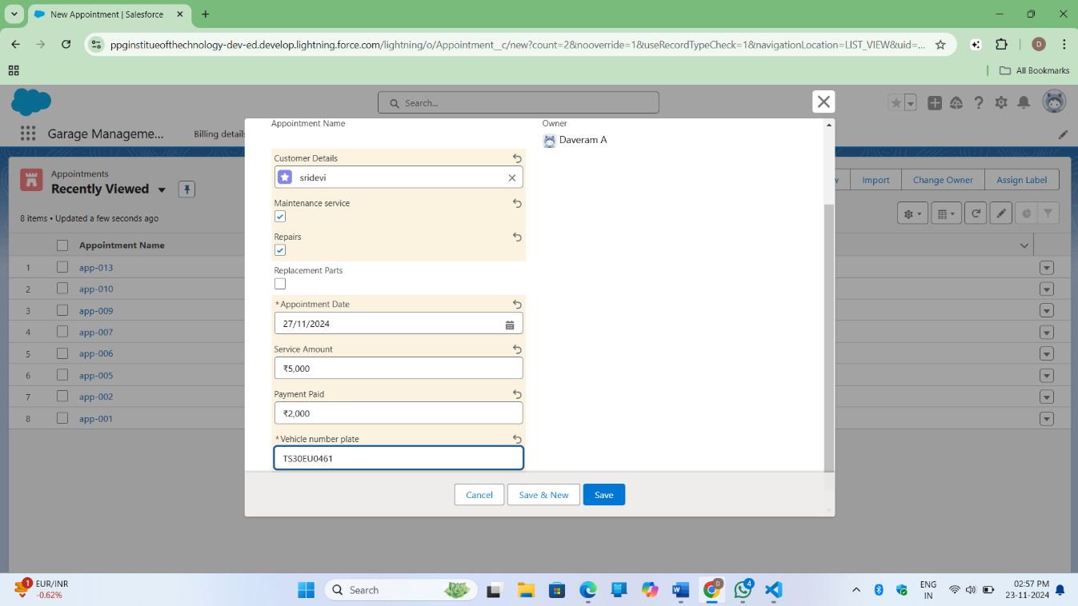
  1. Created a record in the "Consumer Details" tab.
  2. Created an Appointment record with customer details, appointment date, vehicle number plate, and selected services.
  3. Created a Service record, set "Quality Check Status" to "True," and the "Service Status" updated to "Completed" automatically.

**Milestone 16: Reports**

**Activity 1: Create Report Folder**

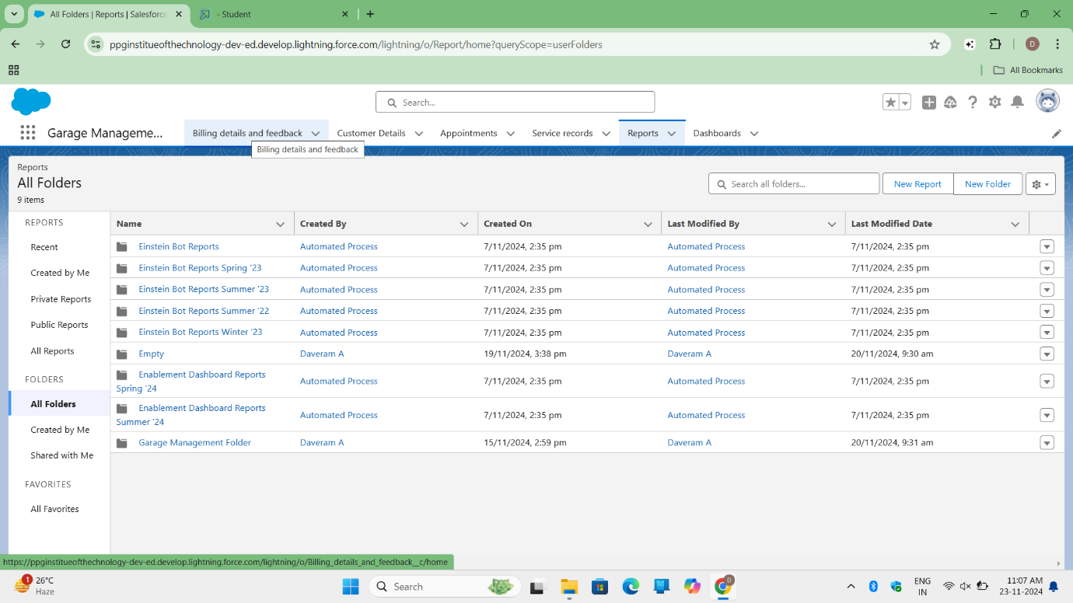

* 1. Created a new folder titled "Garage Management Folder" in the Reports tab.

**Activity 2: Sharing Report Folder**

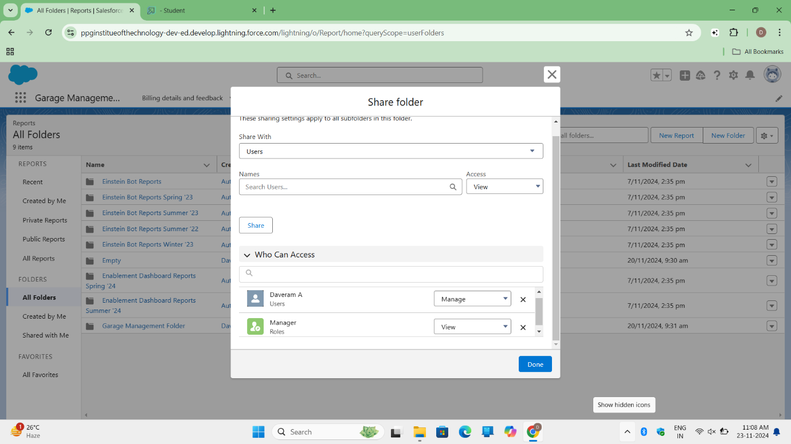

* 1. Shared the "Garage Management Folder" with the "Manager" role, granting "View" access.

**Activity 3: Create Report Type**

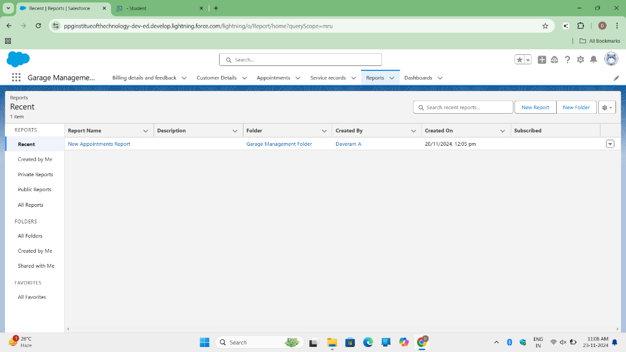

* 1. Created a custom report type named "Service Information," linking "Customer Details," "Appointment," "Service Records," and "Billing Details and Feedback."

**Activity 4: Create Report**

* 1. Created a new report using the "Service Information" report type.
  2. Selected the fields: Customer Name, Appointment Date, Service Status, and Payment Paid.
  3. Grouped data by "Rating for Service" and "Payment Status."
  4. Added a Line Chart for visualization and saved the report in the "Garage Management Folder."

**Milestone 17: Dashboards**

**Activity 1: Create Dashboard Folder** 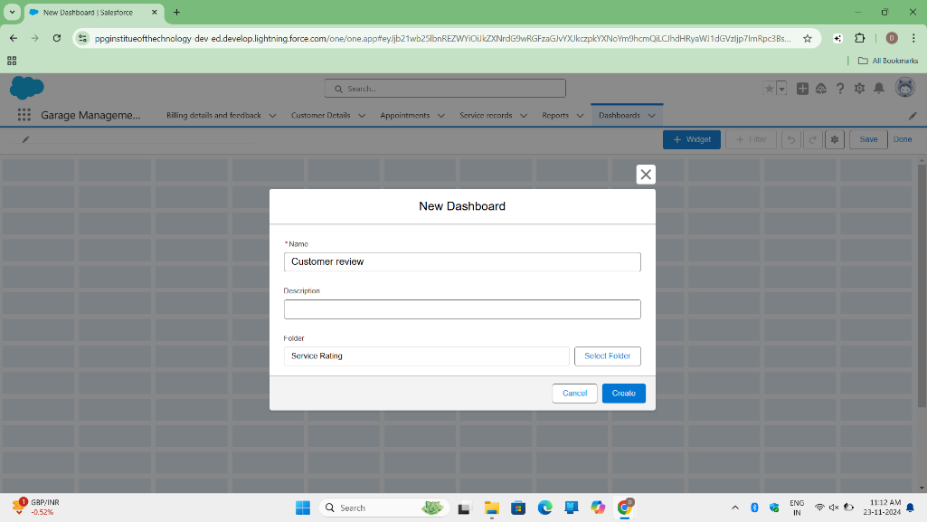

* 1. Click on the App Launcher and search for "Dashboard."
  2. Go to the Dashboard tab and click "New Folder."
  3. Name the folder "Service Rating Dashboard."
  4. The folder's unique name is auto-populated.
  5. Click "Save" to create the folder.
  6. Follow the same steps as in Milestone 15, Activity 2, to set up sharing for the "Service Rating Dashboard" folder.

**Activity 2: Create Dashboard**

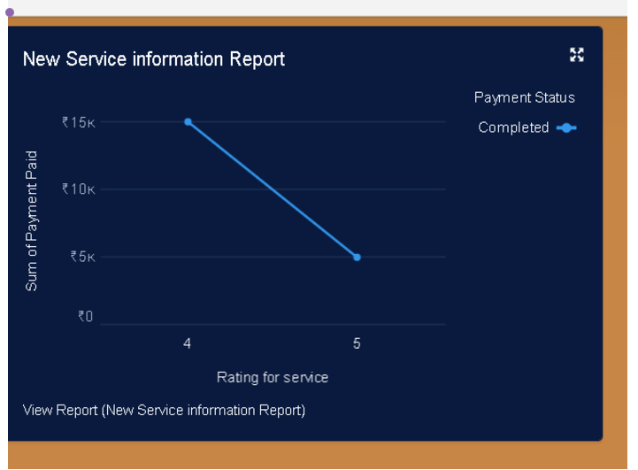

Go to the app and click on the **Dashboards** tab.

1. Enter a **name** for the dashboard and select the folder created earlier, then click **Create**.
2. Click **Add Component** to add a new component to the dashboard.
3. Select a **Report** and click **Select**.
4. Choose a **Line Chart** and change the theme as needed.
5. Click **Add**, then click **Save** and **Done** to complete the dashboard creation.
6. The preview of the dashboard will be displayed once saved.
7. Click on **Subscribe** at the top right of the dashboard.
8. Set the **Frequency** to "Weekly".
9. Select **Monday** as the day for the report.
10. Click **Save** to complete the subscription.